Day 5

Express

Framework

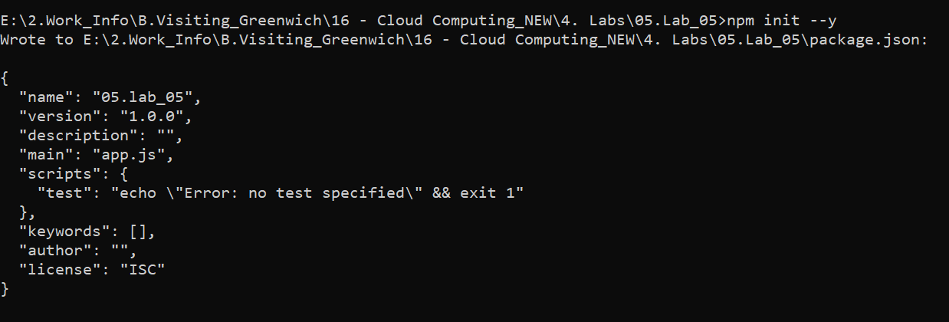

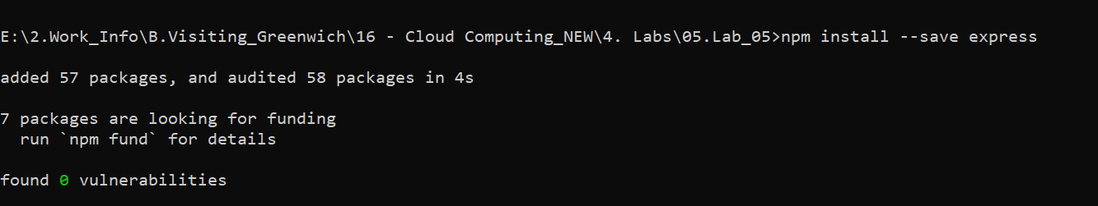

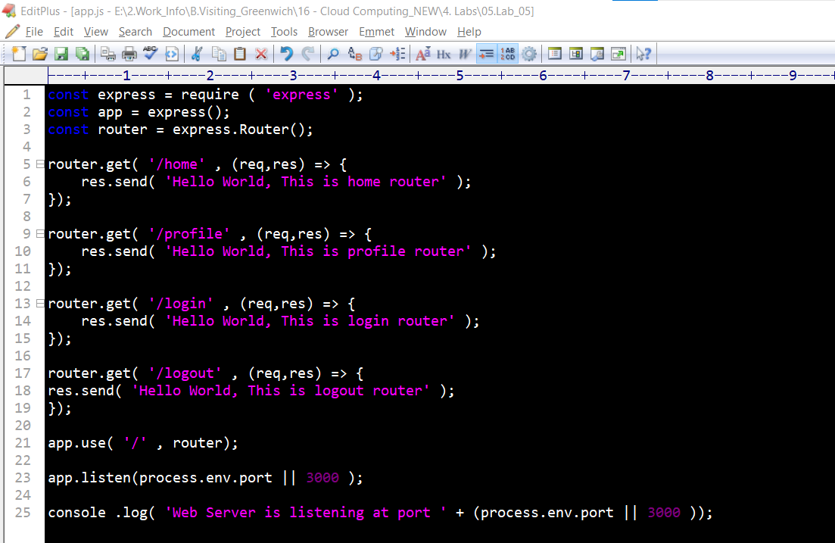



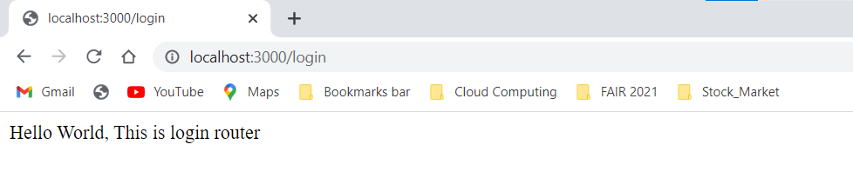

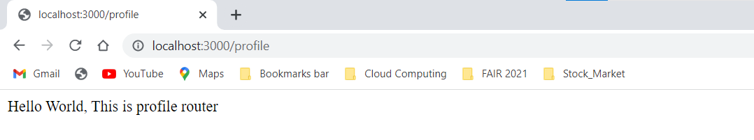

**Application middleware**

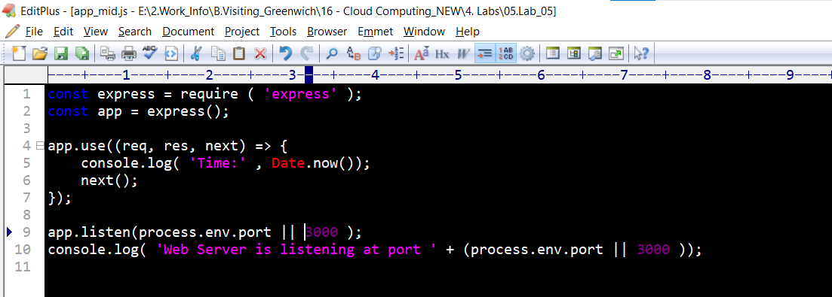



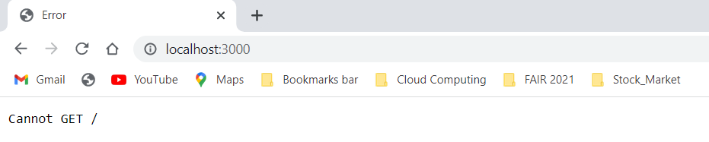

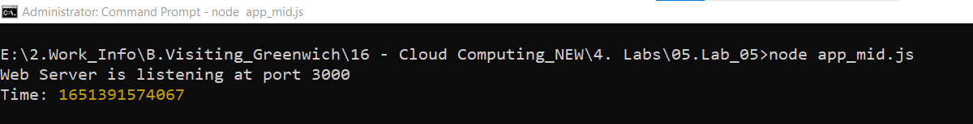

**Router middleware**

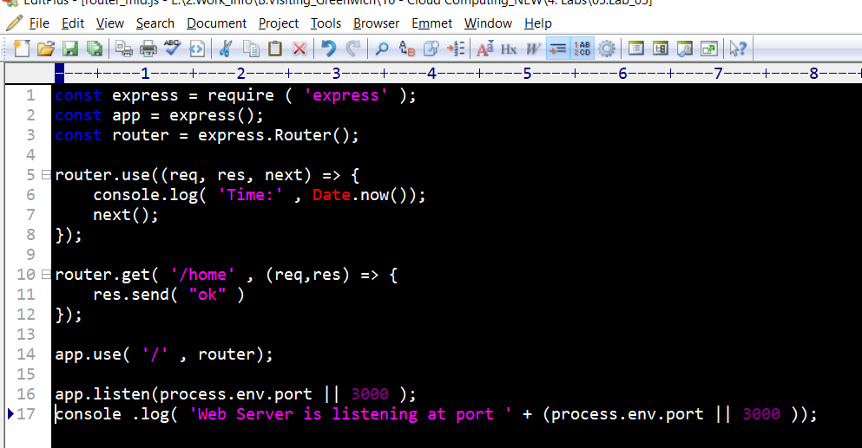



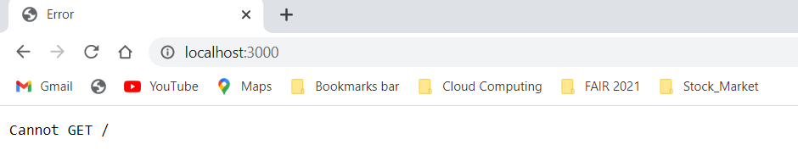

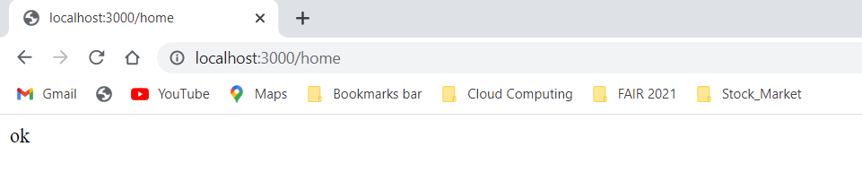

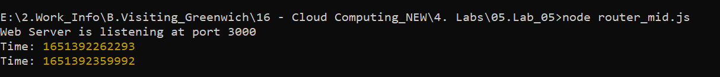

**Error-handling middleware**

**Reference:** https://codeforgeek.com/error-handling-in-express-using-middleware/

Create new directory and generate **package.json** in it. Recommended way is to use **npm init** command.

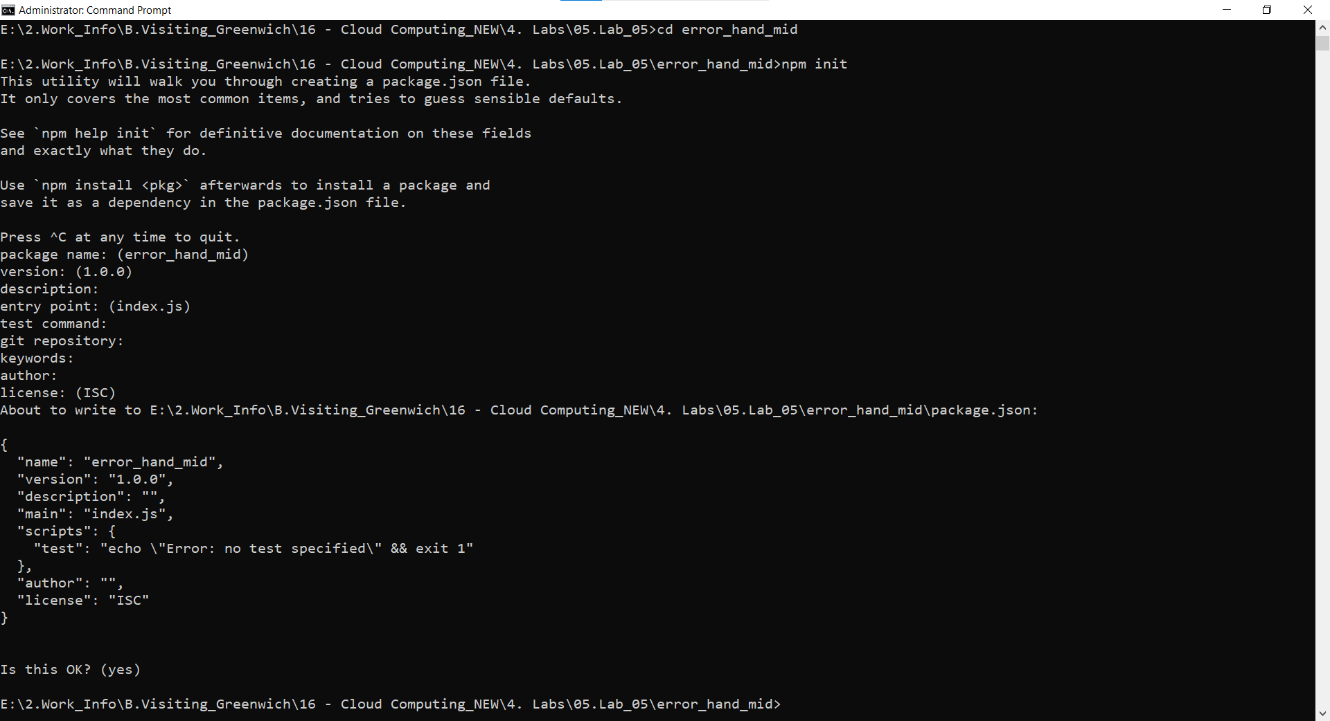

File: **package.json**

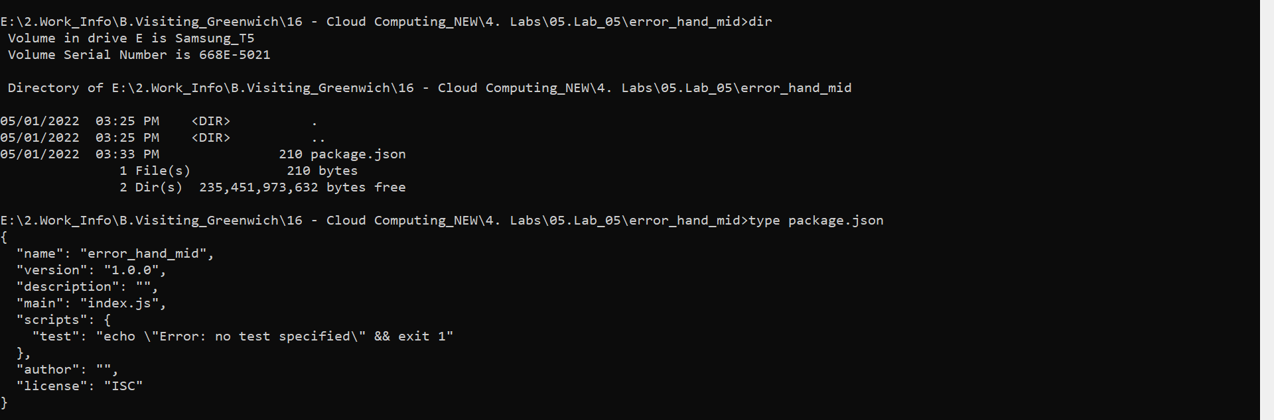

Let’s install **Express** module. Run following command in terminal to install it in your project.

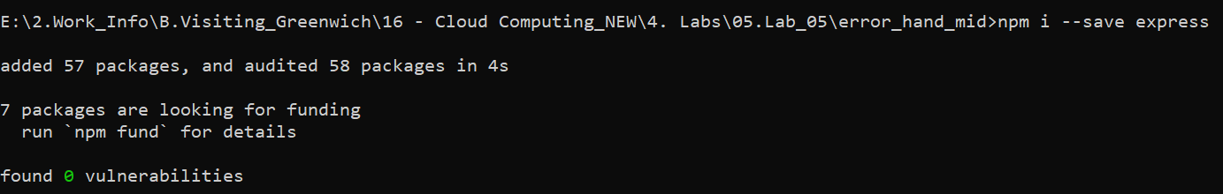

File: **server.js**

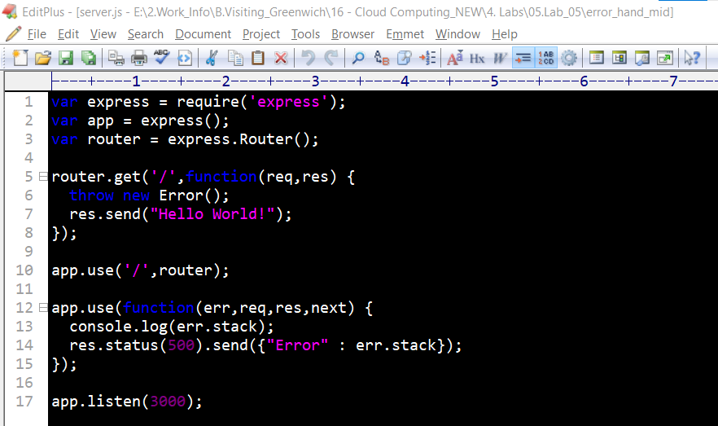



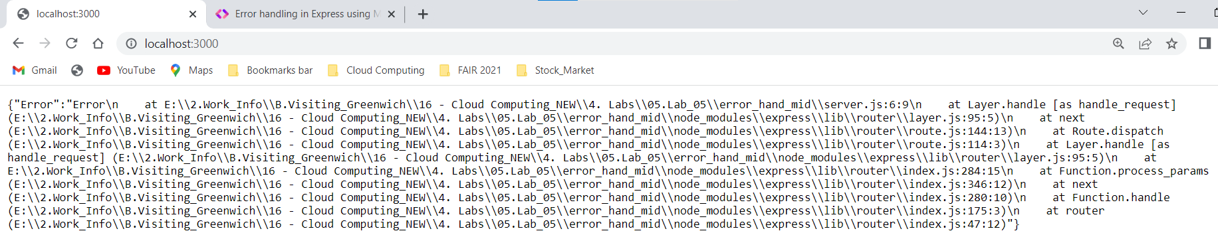

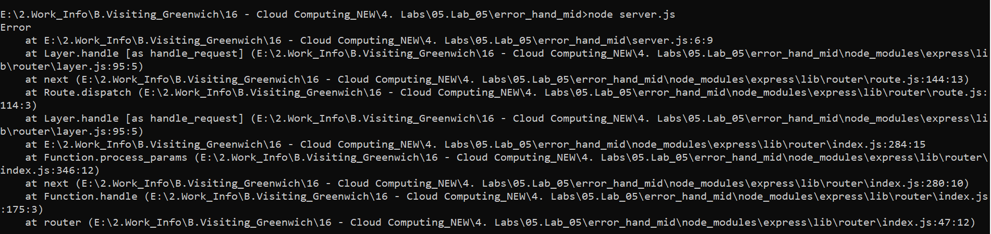

**Third-party middleware**

